Heatmap:

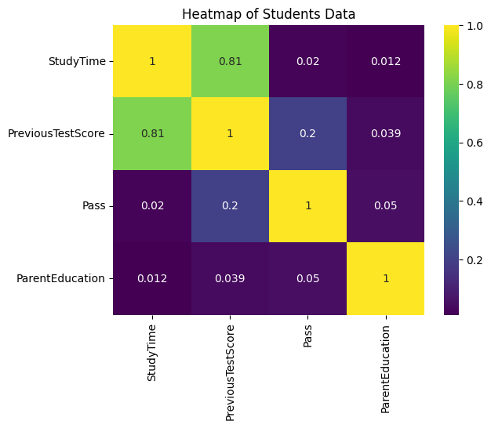

Accuracy Score :

